TASK 1 : 7 Day Content Calendar

POST IDEA | CAPTION | HASHTAGS
Myth vs Fact post | Myth: Internships are only for the toppers!  Fact: Skills matter! NOT marks! Join CodeAlpha and grow your career ! | #MythvsFact  #CodeAlpha  #Internships  #Students  #Careergrowth
Reel: If internships were like a Netflix series | If internships were like a series, CodeAlpha would be the one everyone would bingewatch! Skills, projects, certificate and career growth all in one. Apply now: | #InternshipReel #Trending #CodeAlpha #Students #Career
Reel: Google search internship then show result as CodeAlpha | Time to stop searching and start building | #GoogleSearch #Internship #CodeAlpha #Freshers #SkillDevelopment
Reel: Interview rejection to Glowup reel | Rejected because I had no experience so I decided to build experience.  CodeAlpha internship = skills + projects + confidence. | #CodeAlpha#Students #Internship#Certificate#Freshers
REEL:  Chat with friend | Friend: Bro any internship?  Me: Yes CodeAlpha  Friend: Certificate milega?  Me: QR verified  Friend: Link bhej | #internship#CodeAlpha#linkedin#Students#Skillbuildling
REEL: Red Flag v/s Green flag internship | Red flag internship: no tasks, no certificate  Green flag internship: Real tasks, QR based certificate. Choose the green flag. Choose CodeAlpha. | #Redflag#Greenflag#Realprojects#internship#Skilldevelopment
REEL: Marks v/s skills reality check | College: “Score good marks”  Companies: ‘Show skills and projects”  That’s when I realized internships matter. Starting my CodeAlpha journey now! | #RealityCheck #Students #Internship #CodeAlpha #SkillDevelopment #CareerGrowth #Freshers

TASK 2 : SEO and Keyword Search

Here are 20 key words that CodeAlpha can use for blogs and posts.
- Best internships for students
- Internships with certificate
- Online internship with certificate
- Internship with LOR
- QR verified internship certificate
- Work from home internship for students
- Digital marketing internship online
- Internship to build resume
- Best internship platform in India
- Summer internship program for students
- Free internship for college students
- Linkedin internship opportunities
- Online skill development
- Internship opportunities for freshers
- Coding internship with certificate
- Internship with offer letter
- Placement support internship
- Part time internship for students
- Virtual internships for students
- Online internship program 2026
TASK 4 : Promotional posts

Concept 1
A pixel art poster explaining what codealpha does by using a gaming theme. It explains how CodeAlpha can help to ‘level up’ the skills of students.
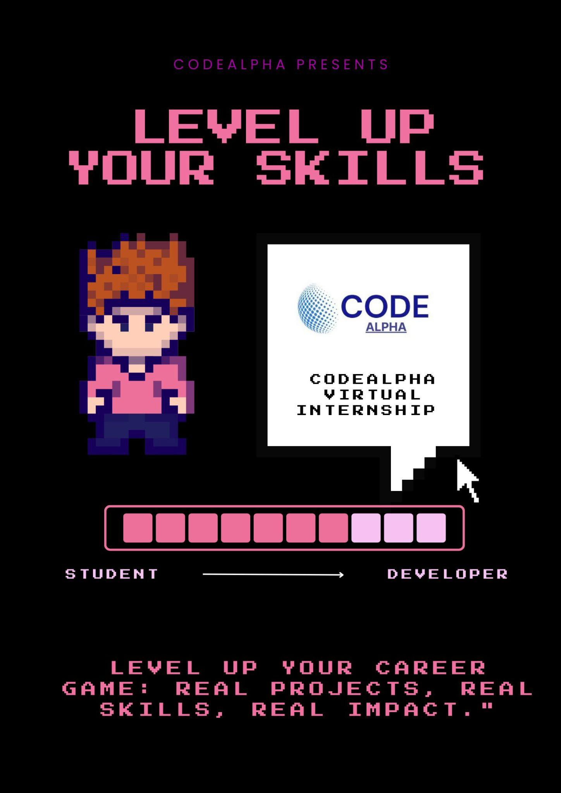

Concept 2

